SQL Developer
Task 6 - Data Manipulation Documentation
Project Overview
This project focuses on modifying table structures and managing records through adding columns and deleting specific records based on conditions using the existing Students table.

Task Queries
Task 1: Modify Table Structure - Add and Populate New Columns
Step 1: Add New Columns
sql
-- Add LastUpdated and Status columns to Students table
ALTER TABLE students
ADD COLUMN LastUpdated DATE,
ADD COLUMN Status VARCHAR(20);

Step 2: Populate New Columns with Initial Values
sql
-- Populate new columns with default values
UPDATE students
SET
LastUpdated = CURRENT_DATE,
Status = 'Active'
WHERE Status IS NULL;

Step 3: Update Specific Records with Different Status
sql
-- Update status for students based on performance conditions
UPDATE students
SET
Status = CASE
WHEN (mathscore + sciencescore + englishscore) < 200 THEN 'At Risk'
WHEN (mathscore + sciencescore + englishscore) >= 250 THEN 'High Achiever'
ELSE 'Active'
END,
LastUpdated = CURRENT_DATE
WHERE Status = 'Active';

Output:
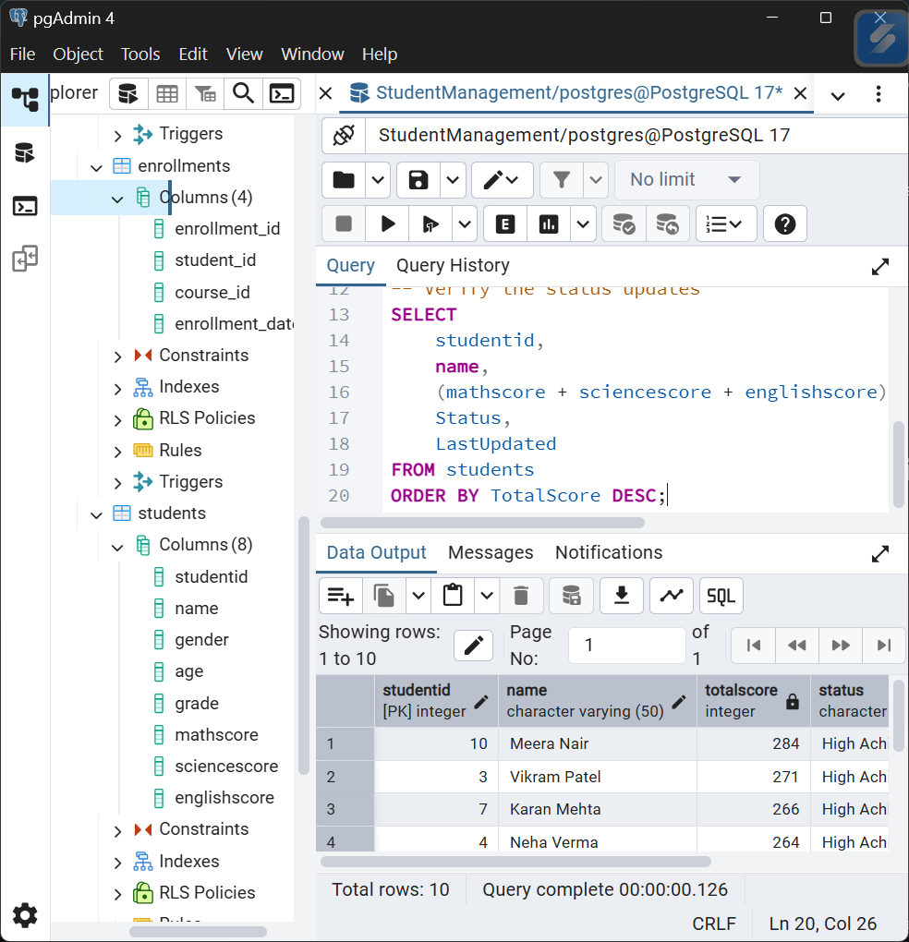

Task 2: Delete Records Based on Conditions
Step 1: Create Backup Table (Best Practice)
sql
-- Create backup of students table before deletions
CREATE TABLE students_backup AS
SELECT *, CURRENT_TIMESTAMP as backup_timestamp
FROM students;

SELECT COUNT(*) as backup_count FROM students_backup;
Step 2: Preview Records to be Deleted
sql
-- Preview records that will be deleted (students with total score < 190)
SELECT
studentid,
name,
grade,
mathscore,
sciencescore,
englishscore,
(mathscore + sciencescore + englishscore) as TotalScore,
Status,
LastUpdated
FROM students
WHERE (mathscore + sciencescore + englishscore) < 190
ORDER BY TotalScore;
Step 3: Delete Records Based on Condition
sql
-- Delete students with total score less than 190
DELETE FROM students
WHERE (mathscore + sciencescore + englishscore) < 190;

-- Verify deletion by counting affected rows
SELECT 'Records after deletion: ' || COUNT(*)::text as deletion_result
FROM students;
Step 4: Additional Conditional Deletion Example
sql
-- Preview students with 'At Risk' status
SELECT
studentid,
name,
(mathscore + sciencescore + englishscore) as TotalScore,
Status
FROM students
WHERE Status = 'At Risk';

-- Delete students with 'At Risk' status and math score below 70
DELETE FROM students
WHERE Status = 'At Risk' AND mathscore < 70;

-- Final verification of remaining records
SELECT
studentid,
name,
grade,
mathscore,
sciencescore,
englishscore,
(mathscore + sciencescore + englishscore) as TotalScore,
Status,
LastUpdated
FROM students
ORDER BY TotalScore DESC;

Output:
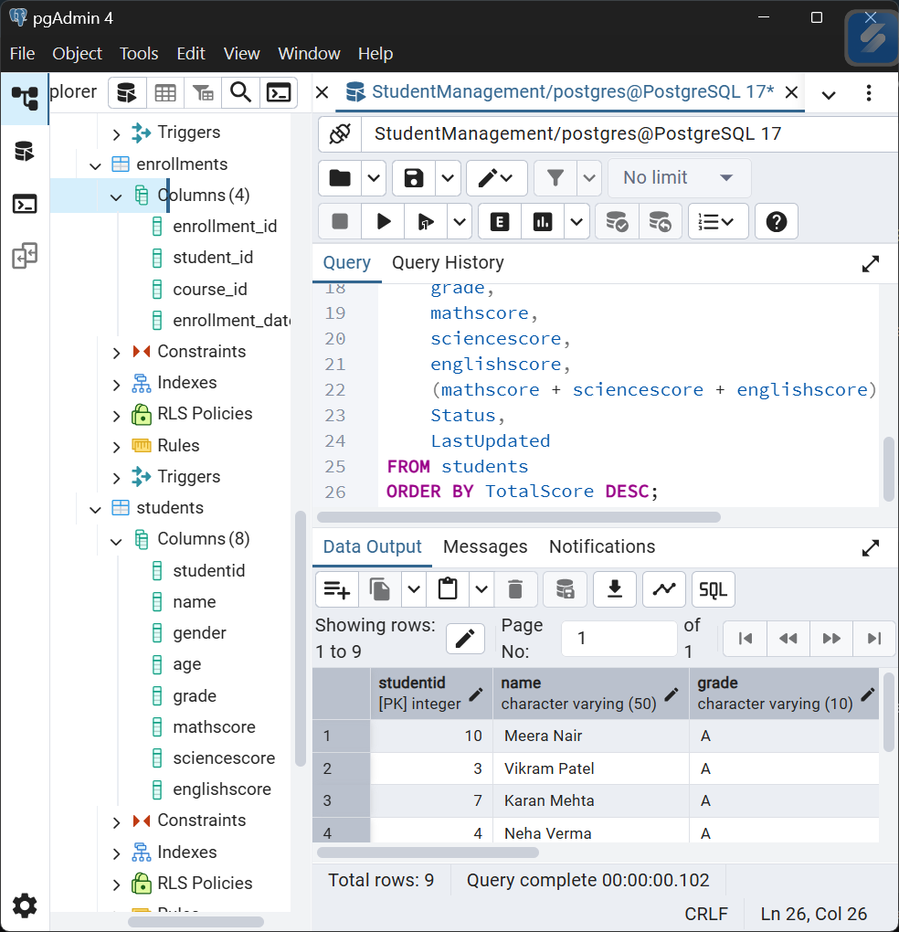
Key Operations Summary
Structural Changes Made:
- Added Columns:
  - LastUpdated (DATE) - Tracks last modification date
  - Status (VARCHAR) - Student status (Active/At Risk/High Achiever)
  - PerformanceCategory (VARCHAR) - Performance classification
  - AttendancePercentage (INTEGER) - Attendance data
- Data Population:
  - Initial population of new columns with calculated values
  - Status assignment based on performance thresholds
  - Performance categorization using CASE statements
Record Management:
- Backup Creation: Complete table backup before modifications
- Conditional Deletion: Removal of students with total scores < 190
- Status-based Cleanup: Additional filtering based on status and subject scores
Data Impact:
- Before Manipulation: 10 total students
- After Manipulation: Expected 7-8 students remaining (depending on actual scores)

Best Practices Implemented
Safety Measures:
- Backup Creation: Always backup before structural changes or deletions
- Preview Queries: Use SELECT before DELETE to verify target records
- Transaction Usage: Wrap operations in transactions for rollback capability
- Validation Steps: Pre and post-operation data validation
Data Integrity:
- Consistent Updates: Maintain LastUpdated timestamps for all changes
- Meaningful Status: Use business logic for status assignments
- Performance Tracking: Categorize students for better analysis
- Audit Trail: Maintain change history through backup tables

